SUPPLEMENTAL MATERIAL

Predictive Models of Seed Yield in Intermediate Wheatgrass (*Thinopyrum intermedium*): The Added Value of a Time Series of Multispectral Imagery in Semiarid Environments

Claire Spickermann 1,2, Efrain Duarte 2,3, Steve Larson 2, Zayne Maughan 4 and Alexander Hernandez 2,*

**Supplemental Figure S1.** Seasonal and Annual Climate Trends at the Richmond Site (2022–2024) a

**a** *Monthly climate data were aggregated to seasonal and annual summaries for total precipitation (a, c) and mean air temperature (b, d) during 2021, 2022, 2023, and 2024. Seasons are defined as: Winter (Dec–Feb), Spring (Mar–May), Summer (Jun–Aug), and Fall (Sep–Nov). Source:* [*https://www.ncei.noaa.gov/access/past-weather/84341*](https://www.ncei.noaa.gov/access/past-weather/84341) *(accessed 7-28-2025).*

**Supplemental Table S1.** Monthly mean temperature (°C) and total precipitation (mm) for Richmond site during 2022, 2023 and 2024 a.

|  |  |  |  |  |  |  |  |  |  |  |  |  |  |  |
| --- | --- | --- | --- | --- | --- | --- | --- | --- | --- | --- | --- | --- | --- | --- |
| **Year** | **Climate Variable** | **Jan** | **Feb** | **Mar** | **Apr** | **May** | **Jun** | **Jul** | **Aug** | **Sep** | **Oct** | **Nov** | **Dec** | **Annual** |
| 2021 | Temp. (°C) | -4.9 | -1.2 | 3.1 | 7.0 | 12.9 | 21.5 | 24.5 | 19.9 | 15.8 | 8.3 | 3.9 | -2.7 | 9.0 |
| 2021 | Precip. (mm) | 20.1 | 28.4 | 15.5 | 26.9 | 13.5 | 0.3 | 10.9 | 53.6 | 0.3 | 89.7 | 12.2 | 22.4 | 293.6 |
| 2022 | Temp. (°C) | -7.8 | -6.3 | 2.6 | 5.7 | 10.6 | 17.3 | 23.6 | 22.1 | 17.8 | 9.4 | -0.8 | -5.1 | 7.4 |
| 2022 | Precip. (mm) | 14.7 | 1.3 | 13.0 | 19.6 | 67.8 | 15.5 | 0.3 | 65.0 | 37.8 | 20.1 | 39.1 | 38.6 | 332.7 |
| 2023 | Temp. (°C) | -5.4 | -8.4 | -3.1 | 5.0 | 15.0 | 16.9 | 23.5 | 21.9 | 16.5 | 9.5 | 3.1 | -0.9 | 7.8 |
| 2023 | Precip. (mm) | 66.8 | 10.9 | 57.7 | 34.3 | 21.6 | 37.6 | 5.3 | 58.2 | 42.4 | 40.1 | 38.4 | 24.1 | 437.4 |
| 2024 | Temp. (°C) | -3.1 | 0.1 | 4.5 | 9.0 | 11.3 | 20.2 | 23.5 | 20.6 | 17.8 | 11.7 | 1.0 | -0.4 | 9.7 |
| 2024 | Precip. (mm) | 34.5 | 64.8 | 61.2 | 54.6 | 25.4 | 7.9 | 19.6 | 6.4 | 7.6 | 19.1 | 22.9 | 27.4 | 351.4 |

*a Annual values represent mean annual temperature and total annual precipitation. Source:* [*https://www.ncei.noaa.gov/access/past-weather/84341*](https://www.ncei.noaa.gov/access/past-weather/84341) *(accessed 7-28-2025).*

**Supplemental Table S2.** List of vegetation indices used as spectral predictors in trait-specific models.

|  |  |  |  |
| --- | --- | --- | --- |
| **Index** | **Description** | **Formula** | **Reference** |
| BGI | Blue green pigment index | B/G | (Zarco-Tejada et al. 2005) |
| BI | Brightness Index | (((R2) + (G2) + (B2))/3)0.5 | (Richardson & Wiegand, 1977) |
| CIG | Chlorophyll Index – green | (NIR/G) – 1 | (Gitelson et al., 2003a) |
| CIRE | Chlorophyll Index – red edge | (NIR/RE) – 1 | (Gitelson et al., 2003a) |
| CVI | Chlorophyll Vegetation Index | (NIR*R)/(G²) | (Vincini et al., 2008) |
| DVI | Difference vegetation index | NIR - RE | (Jordan, 1969) |
| EVI | Enhanced Vegetation Index | 2.5*(NIR-R)/(NIR+6*R-7.5*b+1) | (Huete et al., 2002) |
| EXG | Excess green index | (2*G) – R - B | (Torres-Sánchez et al., 2014) |
| GNDVI | Green Normalized Difference Vegetation Index | (NIR-G)/(NIR+G) | (Gitelson et al., 1996) |
| GLI | Green Leaf Index | (2*G-R-B)/(2*G+R+B) | (Louhaichi et al., 2001) |
| GRVI | Green-Red Vegetation Index | (ρ_green - ρ_red) / (ρ_green + ρ_red) | (Motohka et al., 2010) |
| HI | Primary Colors Hue Index | (2*G-R-B)/(2*G+R+B) | (Escadafal et al., 1994) |
| HUE | Overall Hue Index* | atan(2*(B-G-R)/30.5*(G-R)) | (Escadafal et al., 1994) |
| IHS | Intensity Hue Saturation Index | (R+G+B)/3 | (Cetin & Tepecik, 2016) |
| MGRVI | Modified Green-Red Vegetation Index | (G²- R²)/(G²+ R²) | (Bendig et al., 2015) |
| NDRE | Normalized Difference Red Edge Index | (NIR-RE)/(NIR+RE) | (Gitelson & Merzlyak, 1994b) |
| NDVI | Normalized Difference Vegetation Index | (NIR-R)/(NIR+R) | (Rouse et al., 1974) |
| NGBDI | Normalized green-blue difference index | (G – B)/(G + B) | (Verrelst et al., 2008) |
| NGRDI | Normalized green red difference index | (G – R)/(G +R) | (Tucker, 1979) |
| PSRI | Plant Senescence Reflectance Index | (R-G)/(RE) | (Merzlyak et al., 1999) |
| RGBVI | Red-Green-Blue Vegetation Index | (G²)-(B*R)/(G²)+(B*R) | (Bendig et al., 2015) |
| RVI | Ratio Vegetation Index | NIR/R | (Pearson and Miller, 1972) |
| SI | Spectral Slope Saturation Index | (R-B)/ (R+B) | (Escadafal et al., 1994) |
| TVI | Triangular Vegetation Index | 0.5*(120*(NIR-G)-200*(R-G)) | (Broge and Leblanc, 2001) |
| VARI | Visible Atmospherically Resistant Index | (G-R)/G+R-B) | (Gitelson et al., 2002) |

**Supplemental Figure S2.** Complete variable importance figures for the global models

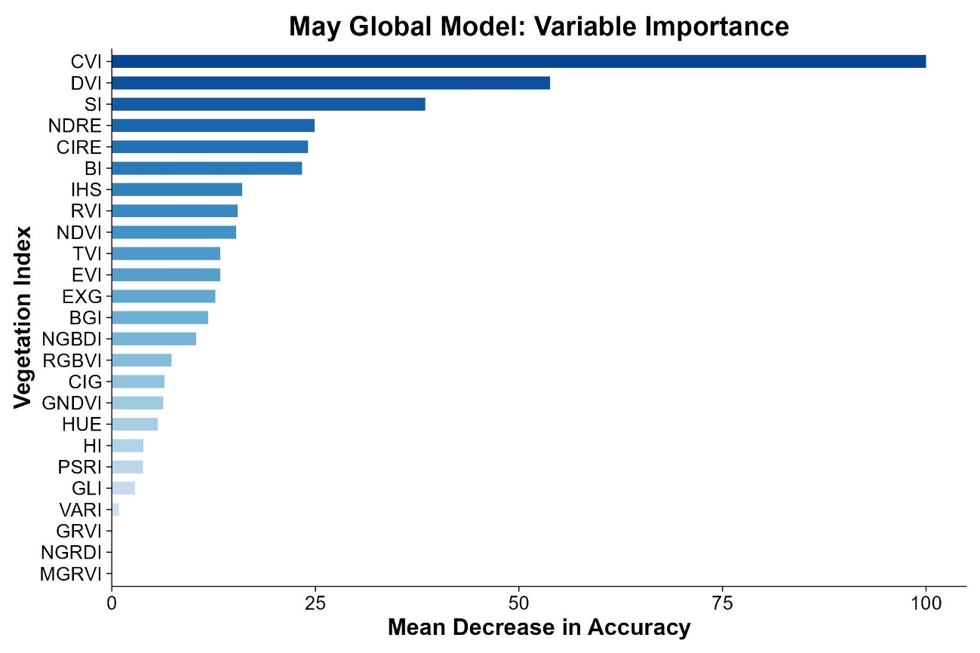

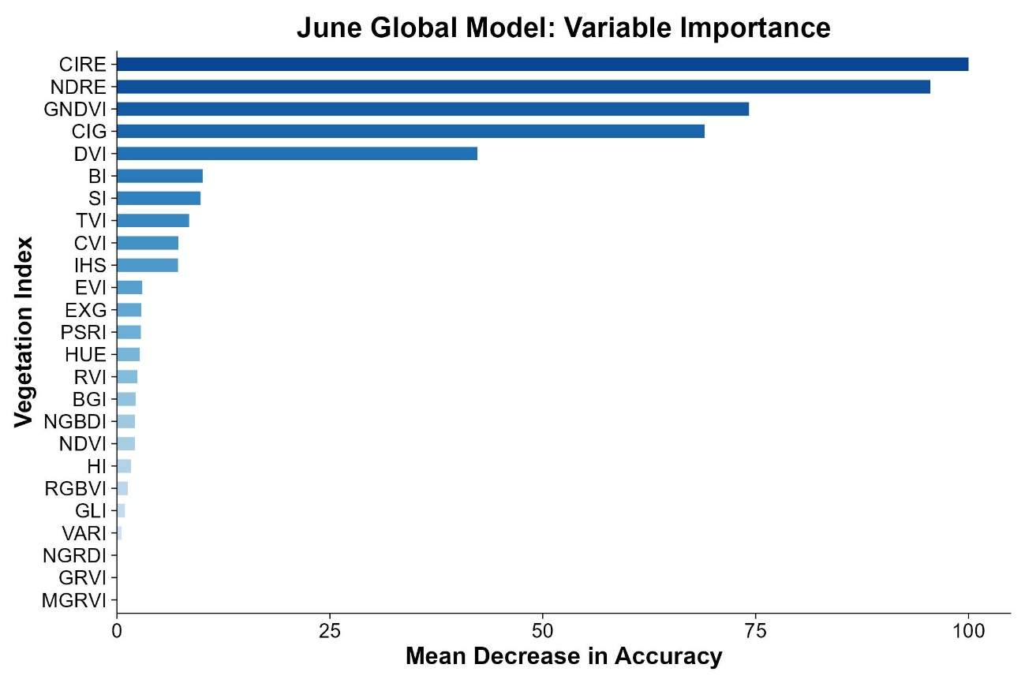

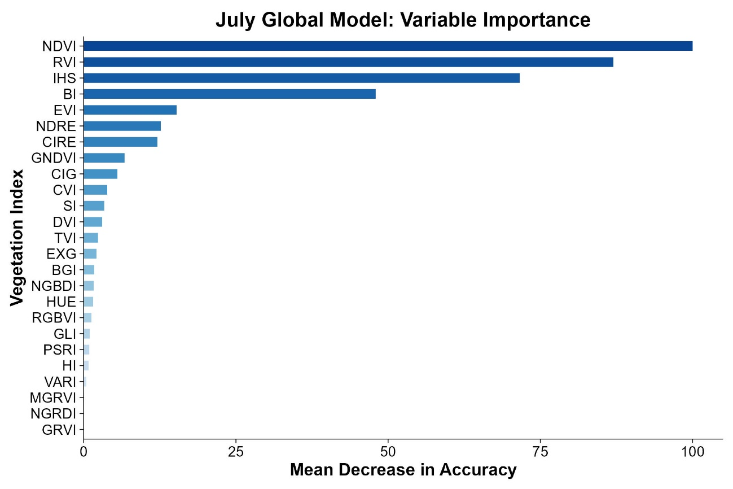

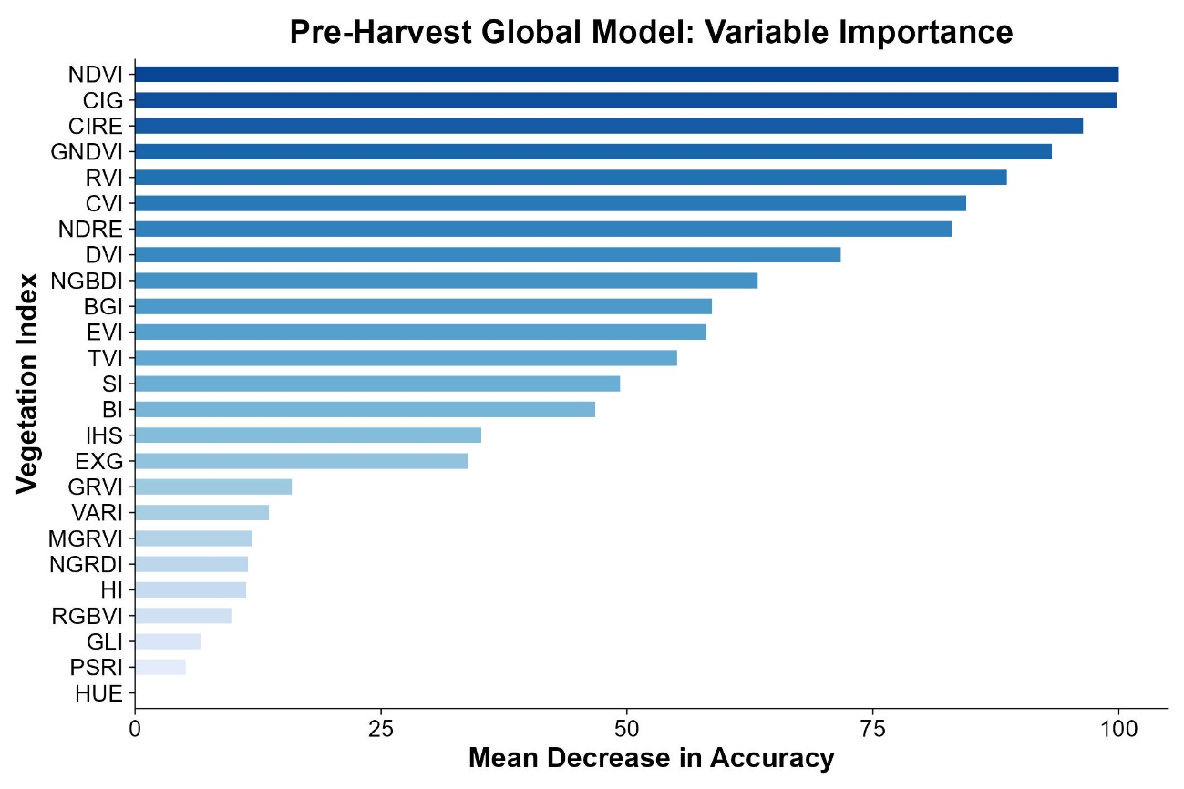

**Supplemental Figure S3.** Observed versus predicted seed yield (kg ha⁻¹) for each Random Forest model using pre-harvest UAV imagery: (a) May 2022 model, (b) May 2023 model, (c) May 2024 model, and (d) May global model (e) June 2022 model, (f) June 2023 model, (g) June 2024 model, (h) June global model, (i) July 2022 model, (j) July 2023 model, (k) July 2024 model, (l) July global model, (m) August 2022 model, (n) August 2023 model, (o) Pre-harvest global model. Shaded areas represent 95% confidence intervals.

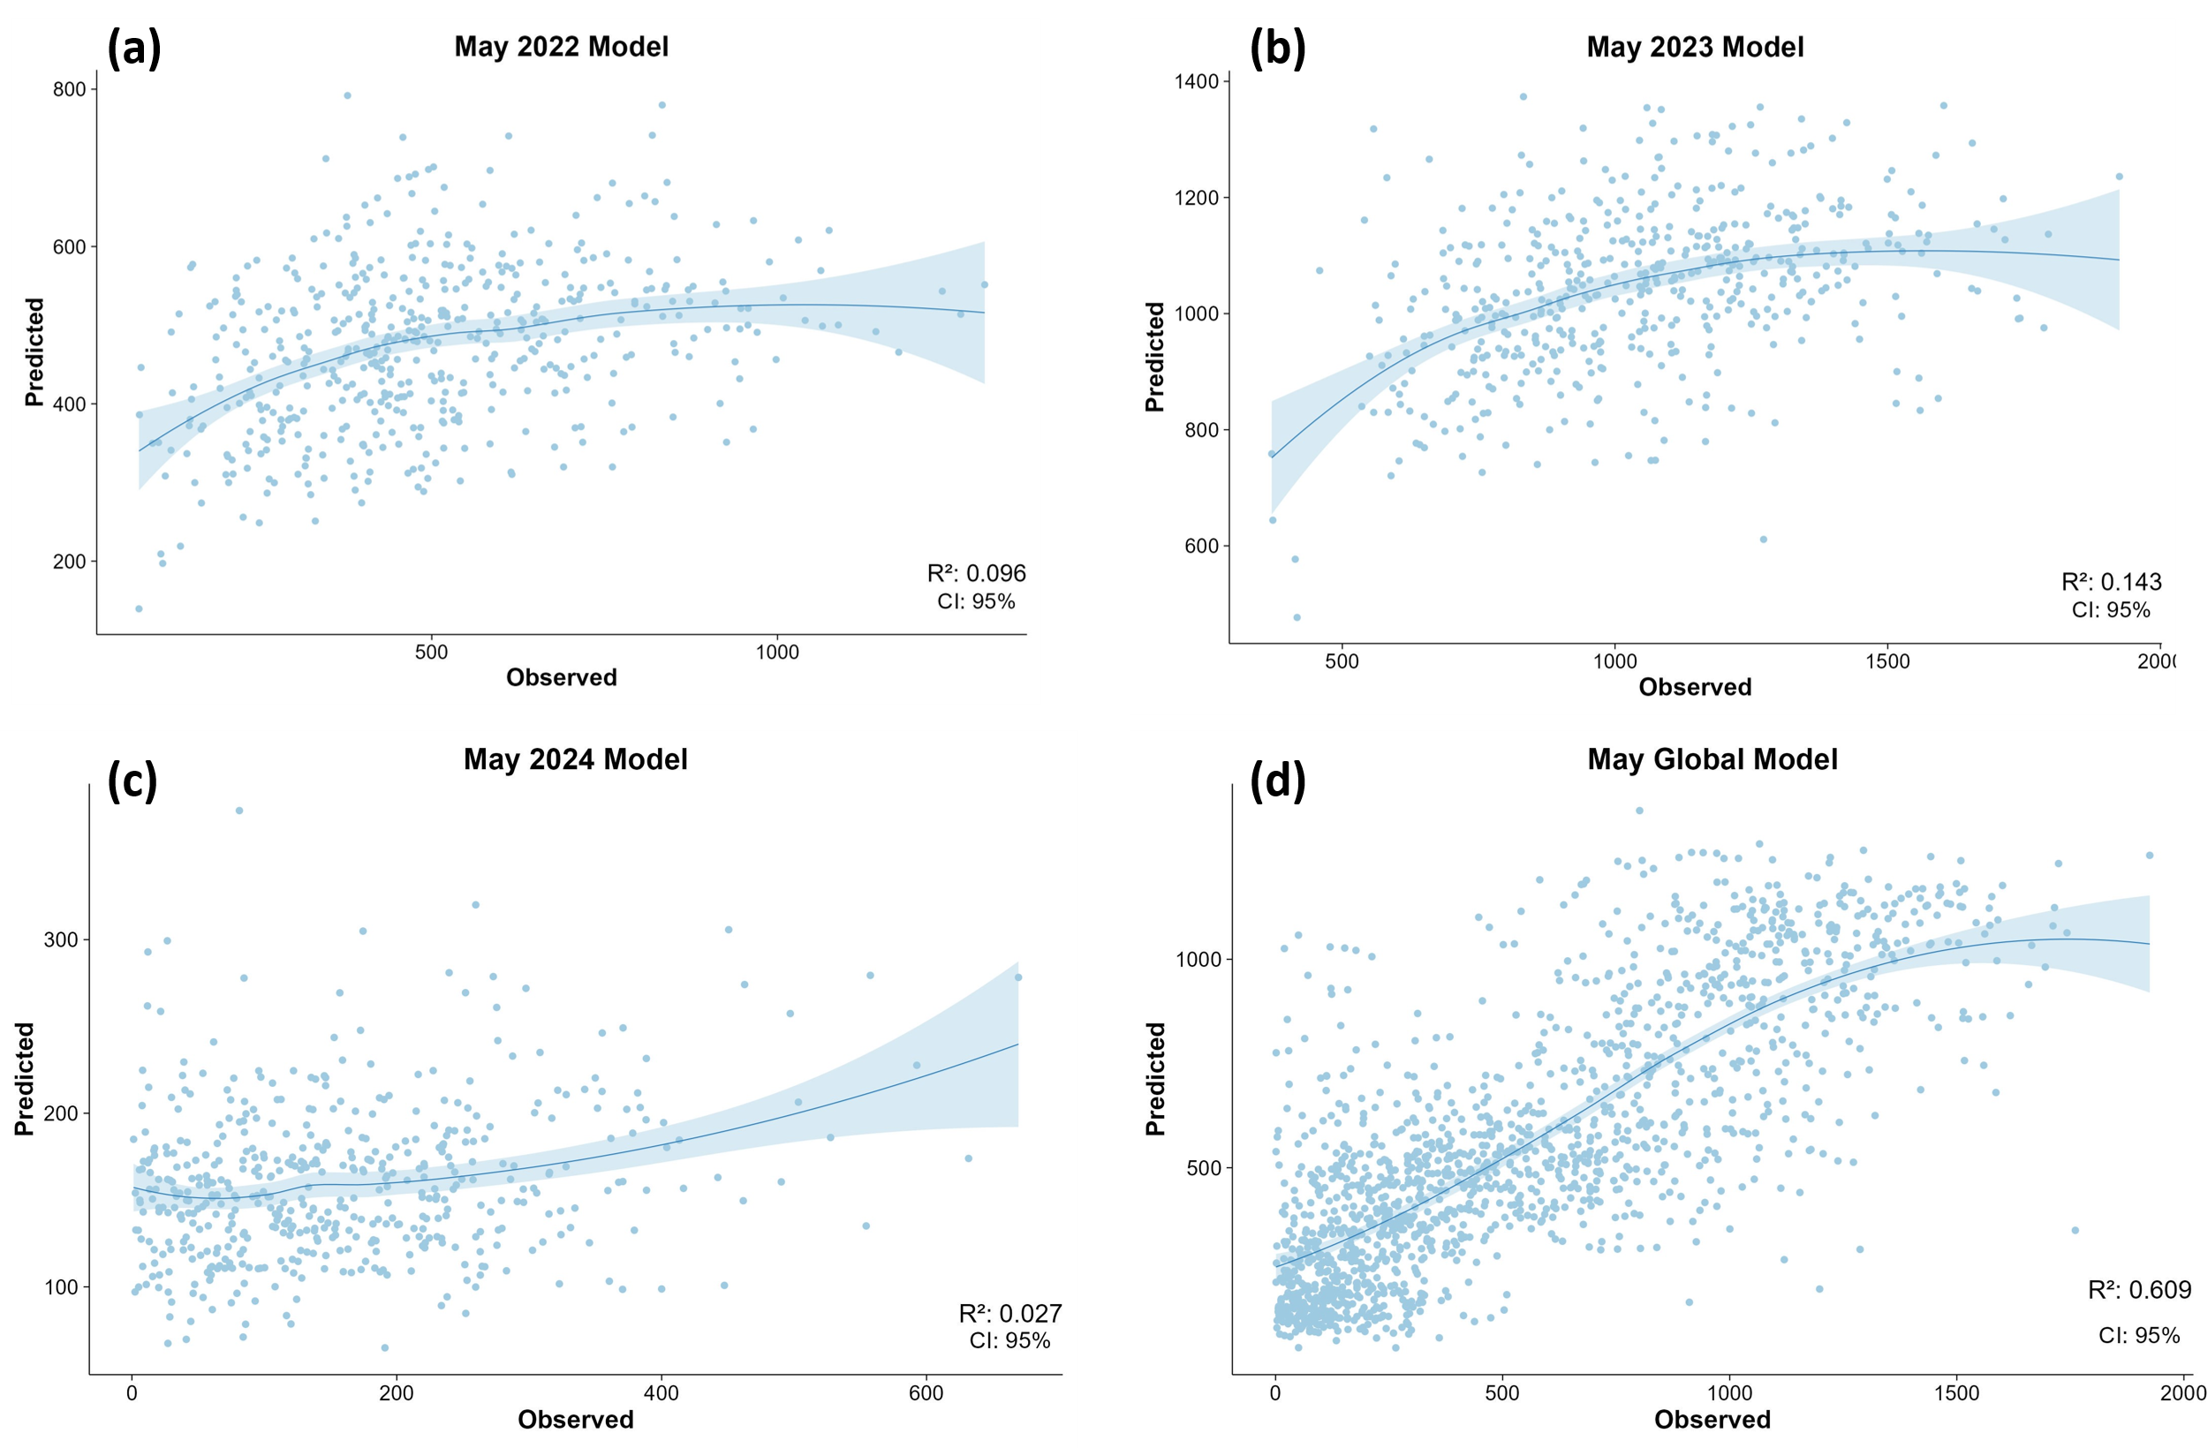

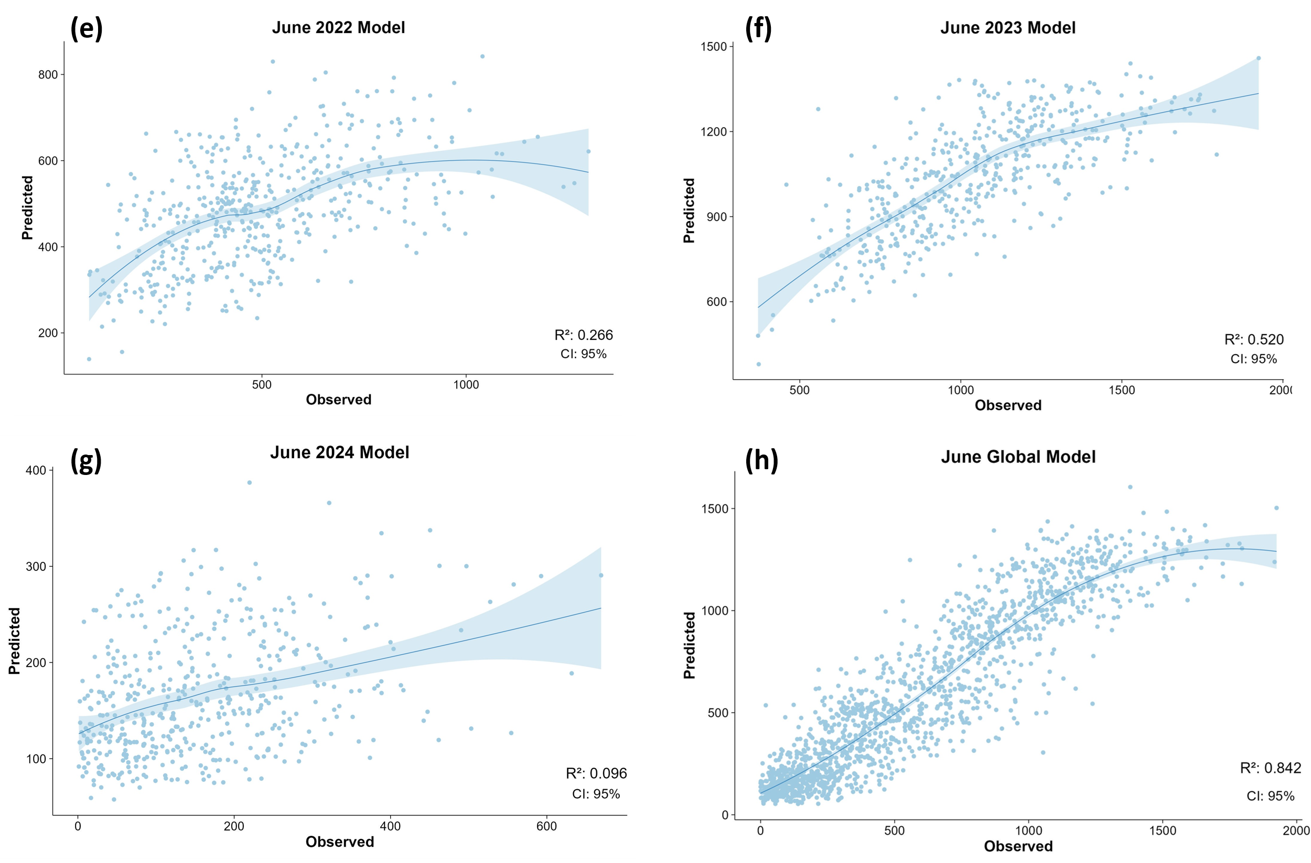

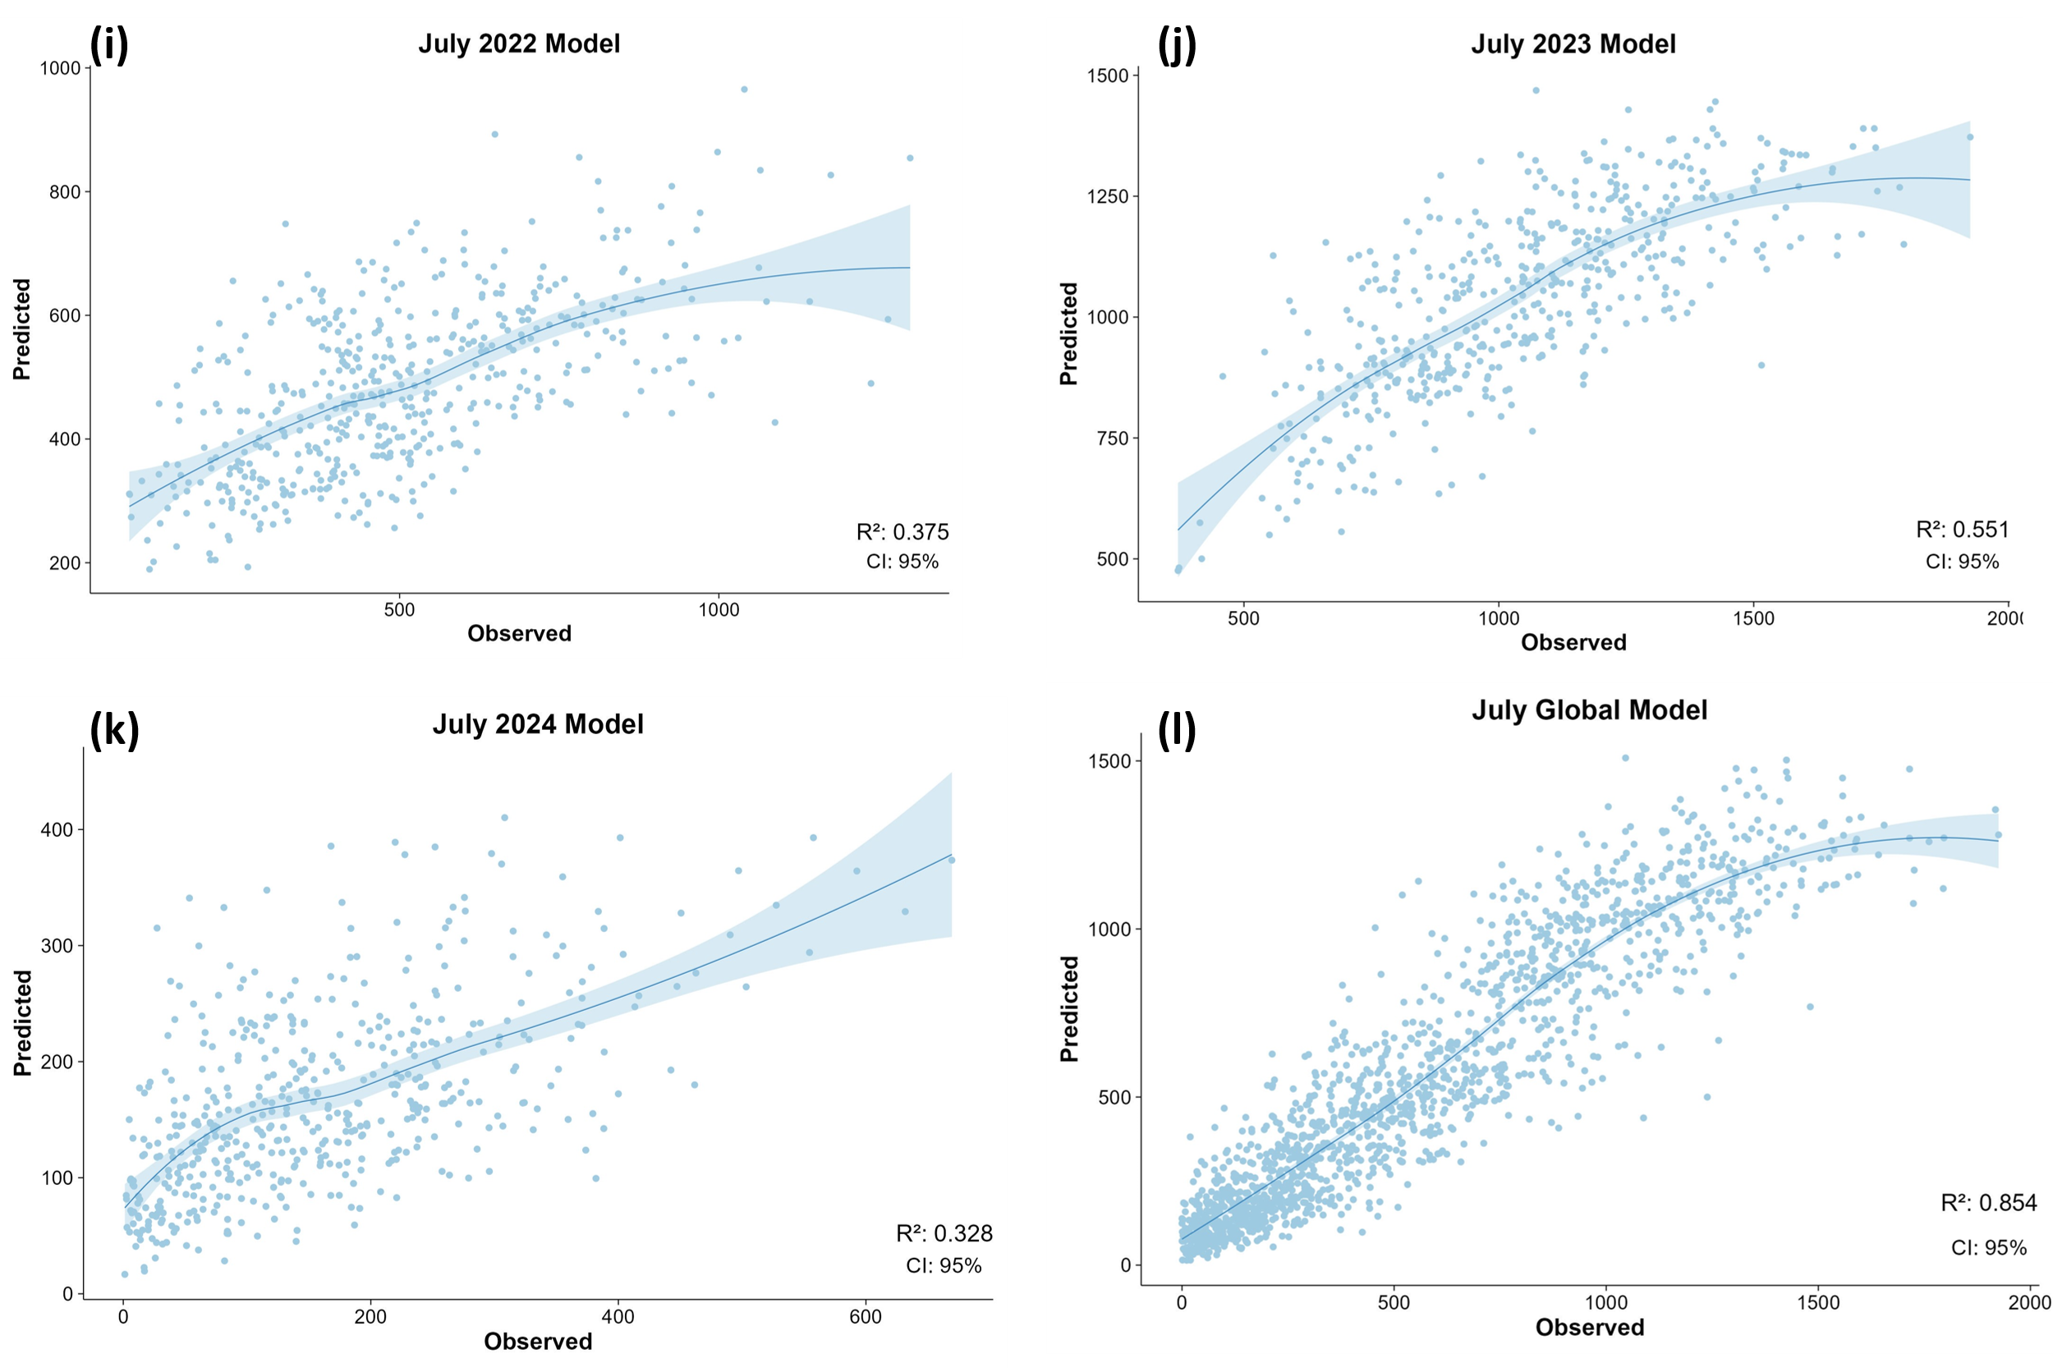

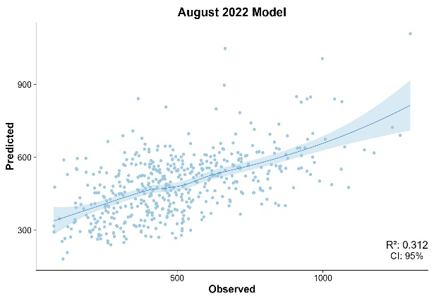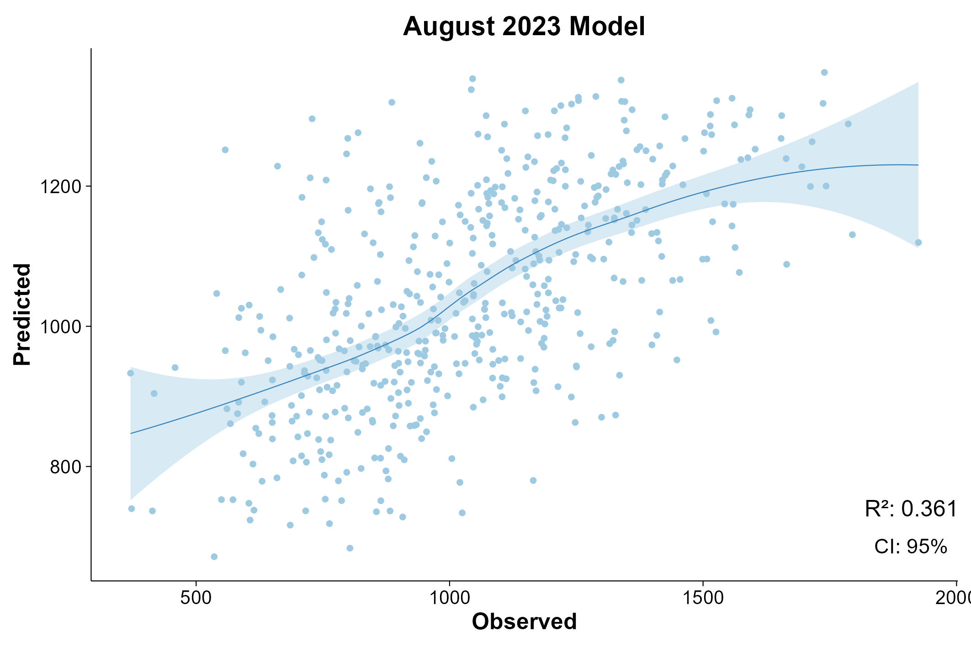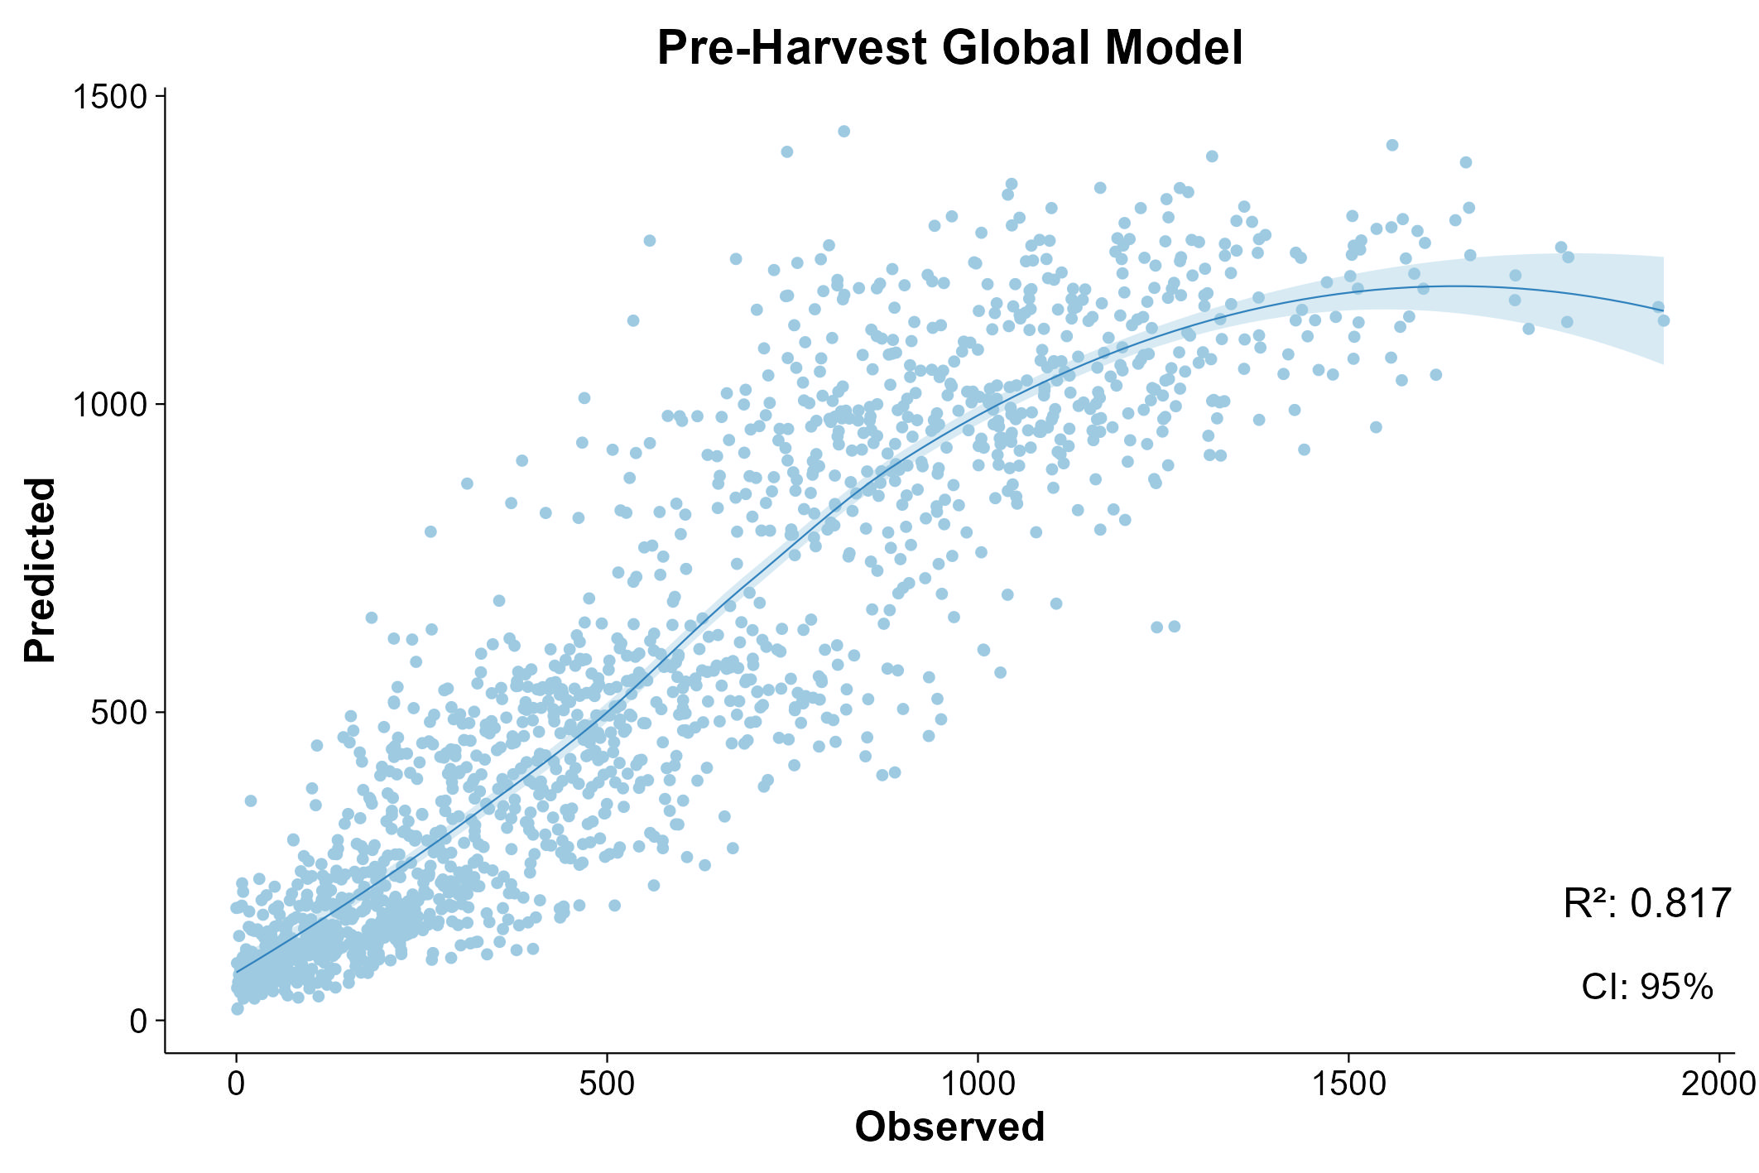

**(m)**

**(n)**

**(o)**

**Supplemental Figure S4.** Residual plots for Random Forest models using UAV-based predictors: (a) May 2022 model, (b) May 2023 model, (c) May 2024 model, (d) global May model, (e) June 2022 model, (f) June 2023 model, (g) June 2024 model, (h) global June model, (i) July 2022 model, (j) July 2023 model, (k) July 2024 model, (l) July global model, (m) August 2022 model, (n) August 2023 model, and (o) Pre-harvest global model. Residuals are plotted against observed seed yield. Positive values indicate underestimation by the model, and negative values indicate overestimation.



